**Advanced Lane Finding**

**Write up** July 18th, 2021 Kenta Kumazaki

**1. Purpose**

The goals / steps of this project are the following:

* Make a pipeline that finds lane lines on the road and calculate curvature and position.
* Reflect on my work in a written report.

**2. Submission**

**(1) GitHub**

<https://github.com/kkumazaki/Self-Drivig-Car_Project2_Advanced-Lane-Finding.git>

**(2) Directory**

<folder: main>

* **Writeup_of_Lesson8.pdf**: This file
* **P2.jpynb**: Pipeline
* Image files video files are saved as following:

**<folder: output_images>**

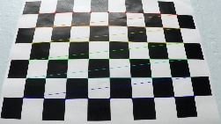 <folder: 1_Calibration >

<folder: before_camera_cal>

Chessboard image before camera calibration.

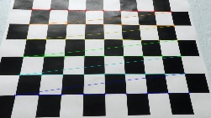<folder: after_camera_cal>

Chessboard image after camera calibration.

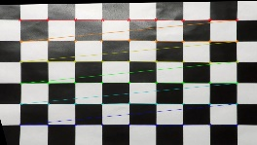 <folder: 2_Undistortion>

<folder: Chessboard>

Undistort and perspective transform of chessboard.

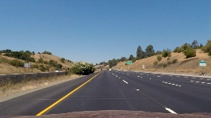<folder: Camera>

Undistort camera images.

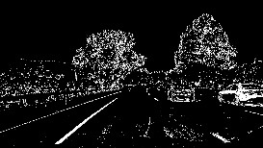<folder: 3_Thresholded>

Color and Gradient threshold images.

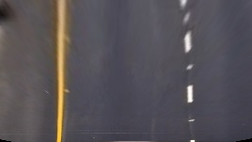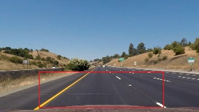  
 <folder: 4_Transform>

<folder: Create>

Straight line images to get transform parameters

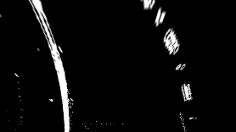 <folder: Adapt>

Adapt parameters and transform curve lines.

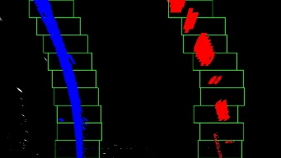 <folder: 5_Finding>

<Histogram>

Calculate by histogram.

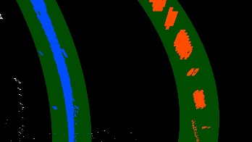 <Prior>

Calculate by prior line info.

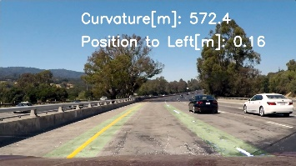 <folder: 6_Result>

Show the lane line area, curvature and position

onto test images.

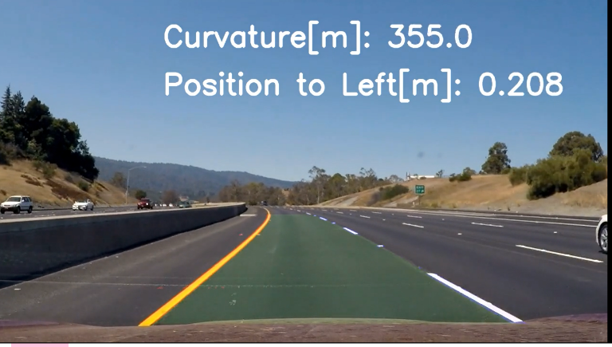**<folder: test_videos_output>**  
 Output of my pipeline onto project_video.mp4.

**3. Reflection**

**(1)Description of my pipeline**

My pipeline consisted of 8 steps.

First, I calibrated the camera by using 20 chessboard images.

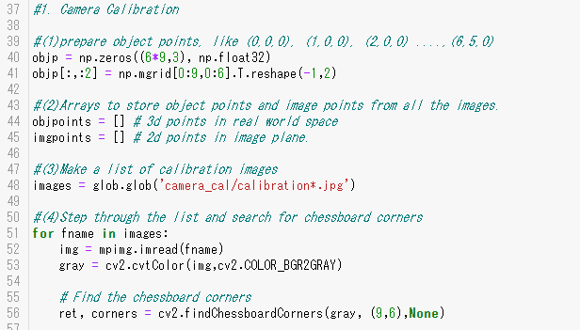

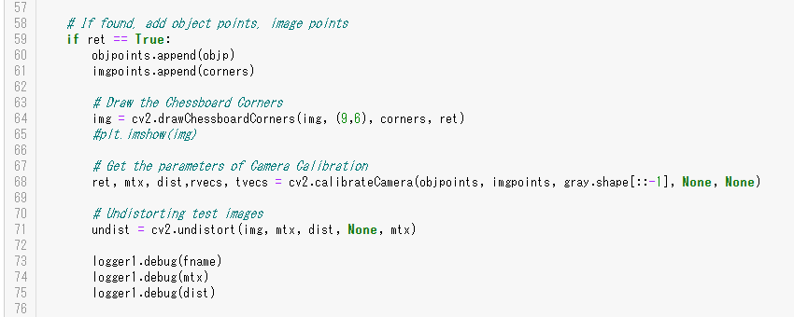

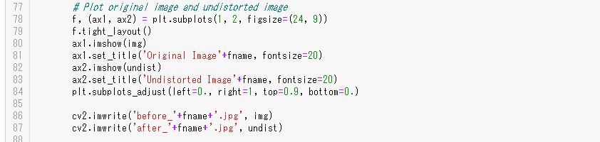

I show one example of distortion correction below. Data folder is “output_images\1_Calibration”.

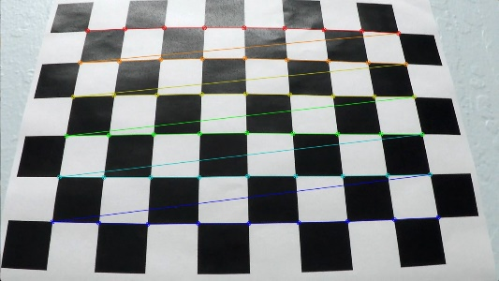 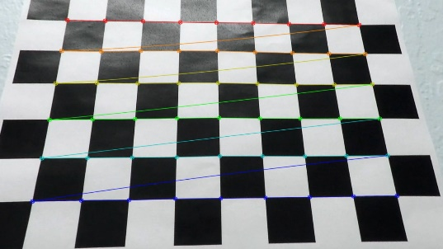

Original image Image after calibration

before_camera_cal /calibration3.jpg after_camera_cal/ calibration3.jpg

I couldn’t use some images for calibration because there are **not enough cross points** as following.

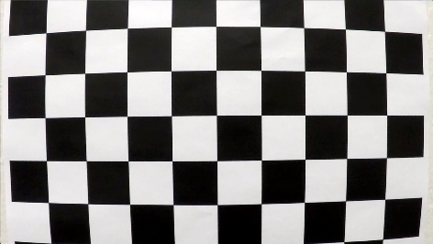 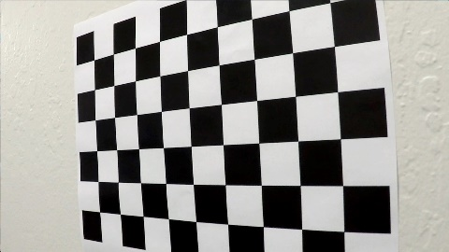 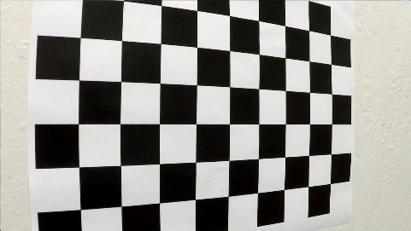

Original image (not for calibration) Original image (not for calibration) Original image (not for calibration)

camera_cal/ calibration1.jpg camera_cal/ calibration4.jpg camera_cal/ calibration5.jpg

Second, I applied distortion correction and perspective transform of Chessboard.

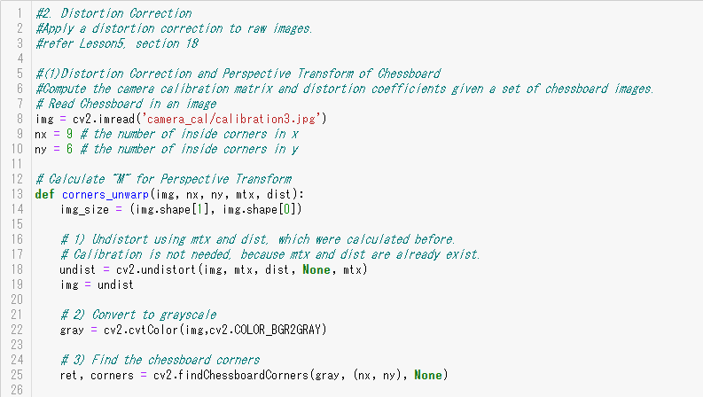

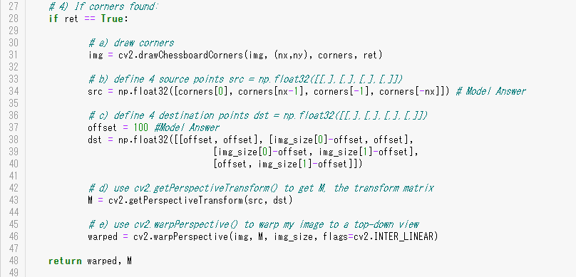

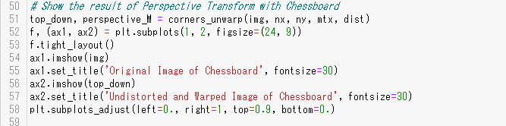

The result of distortion correction and perspective transform of Chessboard is following.

It looks distortion correction and perspective transform works well.

Data folder is “output_images\2_Undistortion”.

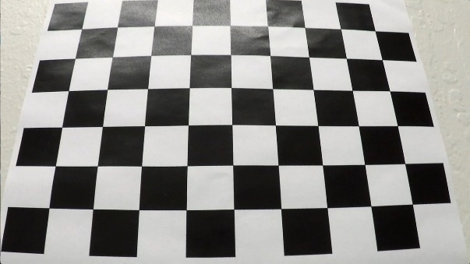 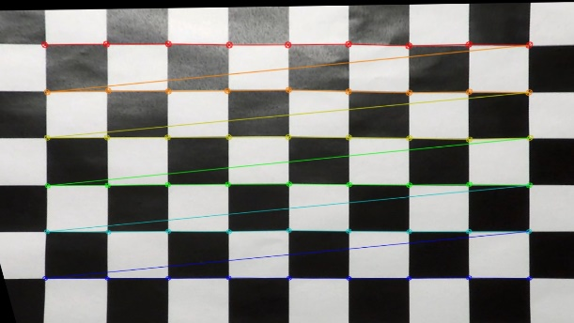

Original image Image after distortion correction and perspective transform

Chessboard/ Original_chess.jpg Chessboard/ Warped_chess.jpg

And also, I adapted distortion correction to the test images.

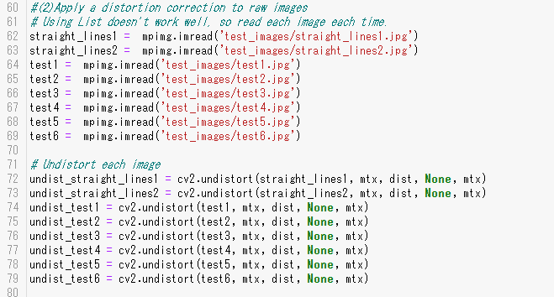

I checked images after distortion correction and they looked as good as the examples of Lesson.

Data folder is “output_images\2_Undistortion\Camera”.

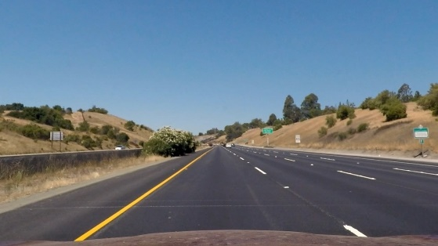 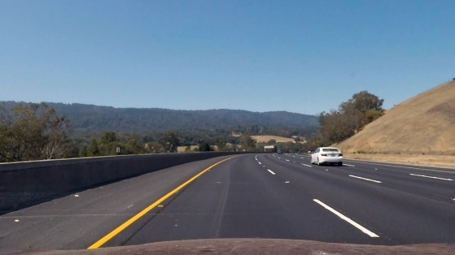

Distortion Correction image (straight) Distortion Correction image (curve)

undist_straight_lines1.jpg undist_test3.jpg

Third, I applied Color Threshold and Gradient Threshold to detect the edges of lane lines.  
I used HLS color space and set threshold on S channel because it has better result than other channels in Lesson.

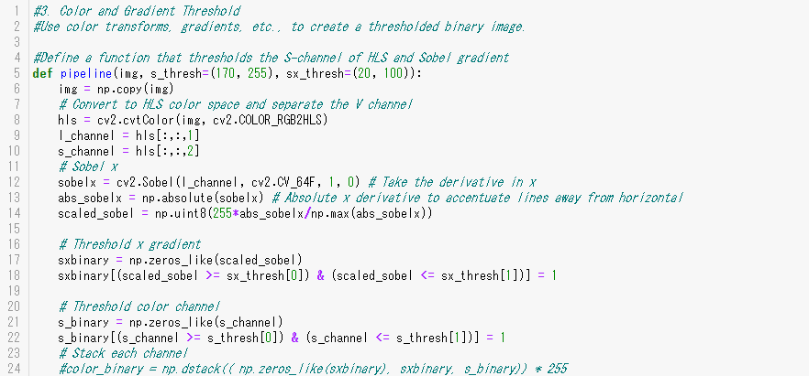

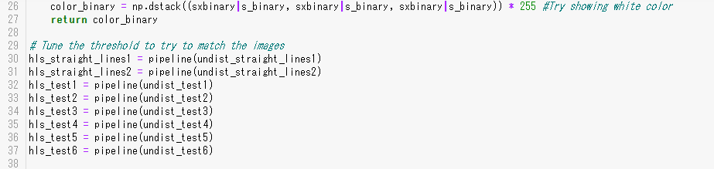

I checked images after threshold and they looked as good as the examples of Lesson.

Data folder is “output_images\ 3_Thresholded”.

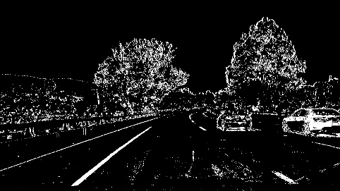 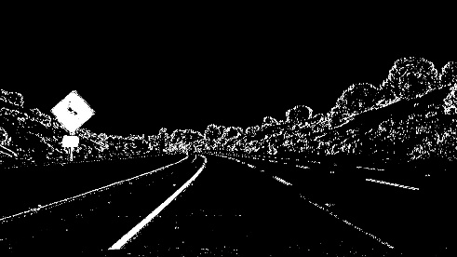 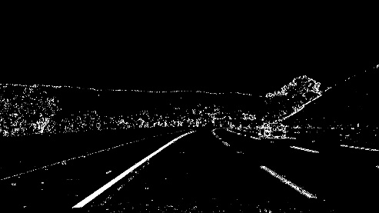

Image after threshold Image after threshold Image after threshold

thresholded_test1.jpg thresholded_test2.jpg thresholded_test3.jpg

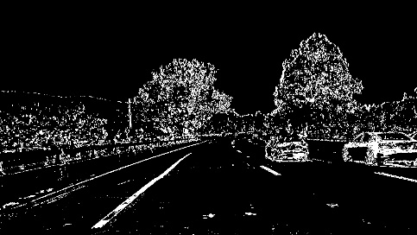 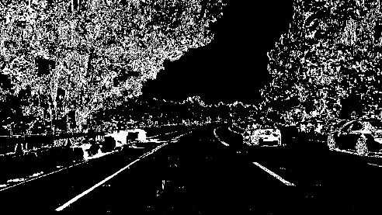 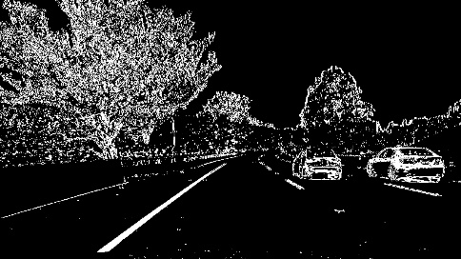

Image after threshold Image after threshold Image after threshold

thresholded_test4.jpg thresholded_test5.jpg thresholded_test6.jpg

Forth, I created bird view of the previous threshold mages.

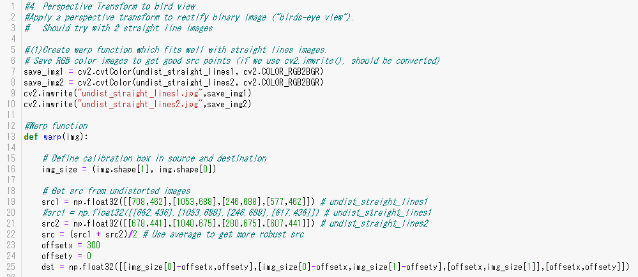

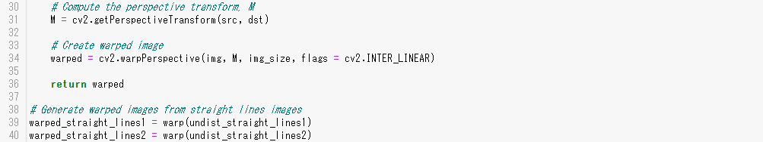

To determine src parameters of Perspective Transform, I used 2 straight line images as below.

I get 2 sets of src (src1, src2) and determine the final src by calculating average of src1 and sec2.

Data folder is “output_images\4_Transform\Create”.

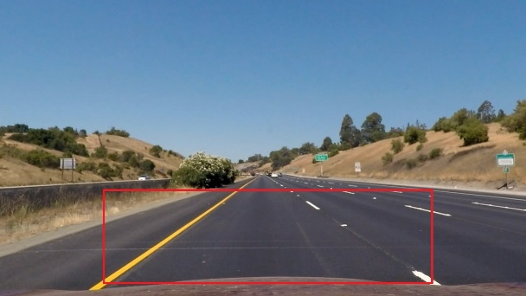 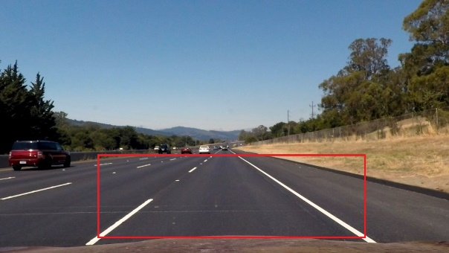

src1 points src2 points

undist_straight_lines1_get_src.jpg undist_straight_lines2_get_src.jpg

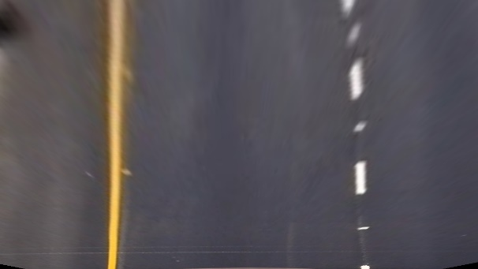 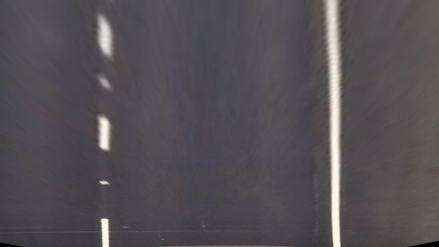

Perspective Transform image Perspective Transform image

warped_straight_lines1.jpg warped_straight_lines2.jpg

By using those parameters, I calculated Perspective Transform of the Images after threshold and   
showed the bird view images as below.

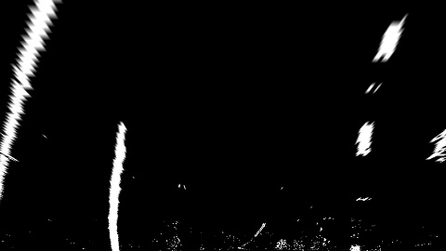 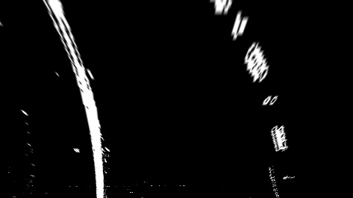 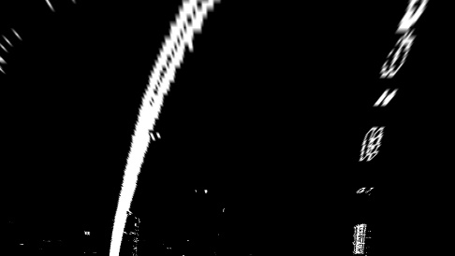

Image after Transform Image after Transform Image after Transform

warped_test1.jpg warped_test2.jpg warped_test3.jpg

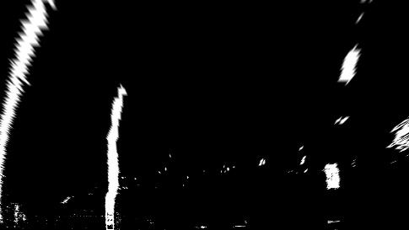 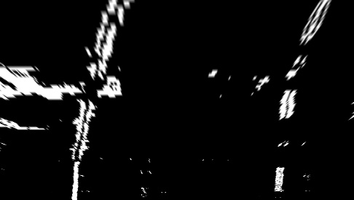 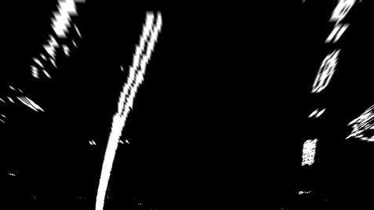

Image after Transform Image after Transform Image after Transform

warped_test4.jpg warped_test5.jpg warped_test6.jpg

Fifth, I found the lane lines in the bird view. There are 4 functions, so I explain step by step.

(1)find_lane_pixels(): Find pixels by using histogram.

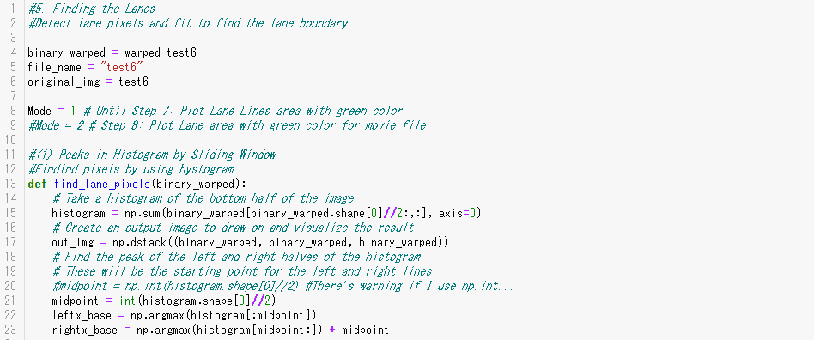

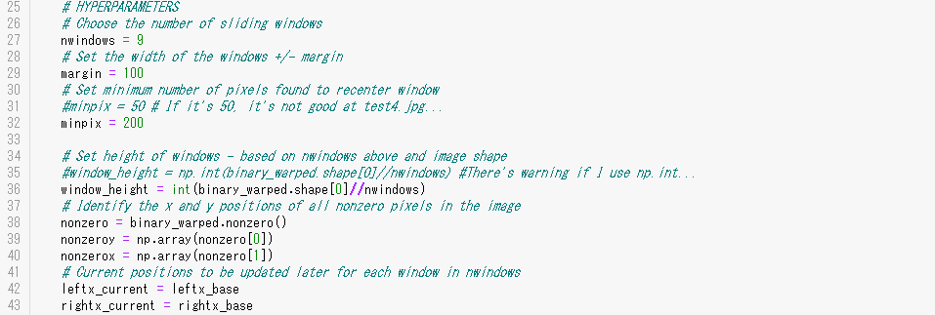

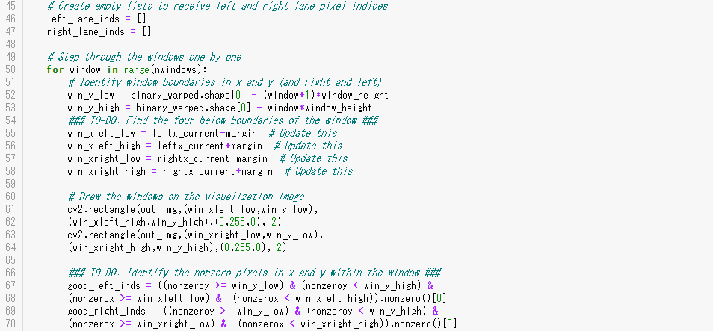

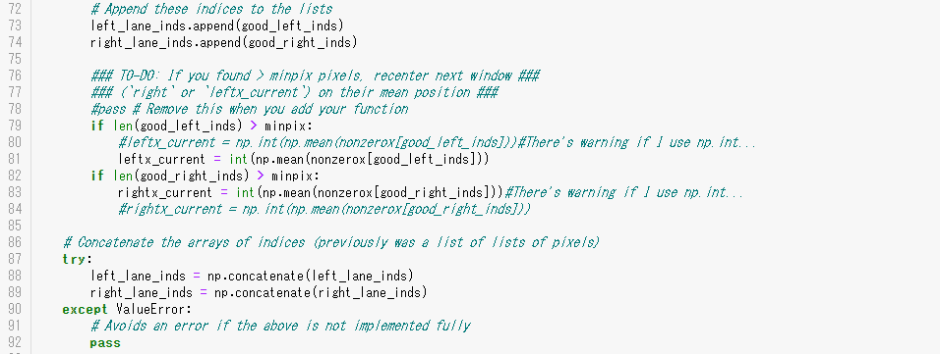

(2) fit_polynomial(): Calculate fitting polynomial by using find_lane_pixels().

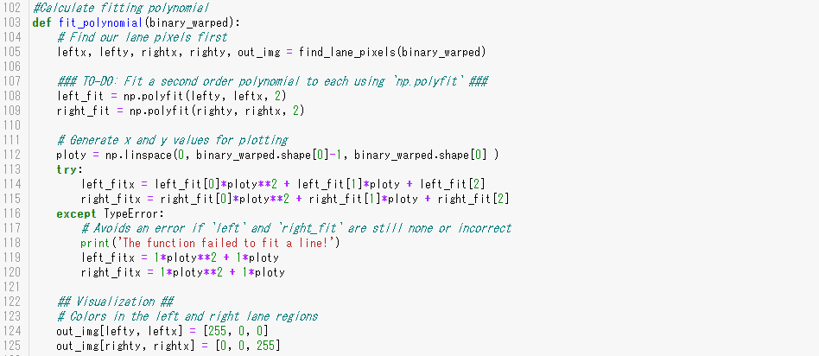

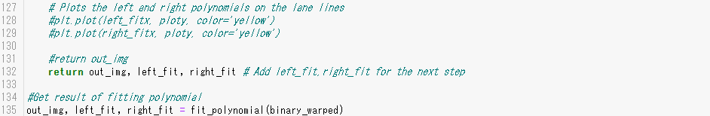

The result of histogram is shown below.

Data folder is “\ output_images\5_Finding\Histogram”.

I used the same parameters as Lesson at first, but the parameter: **min_pix = 50** didn’t work with “test4” image.

It calculated the average of the bottom 4th area **(A),** then bottom 5th area moved to left and the right lane was not detected **(B)**.

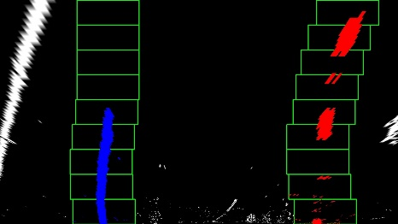 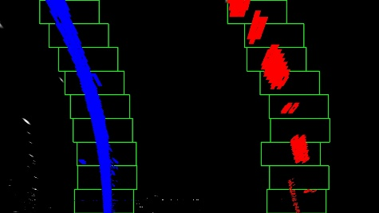 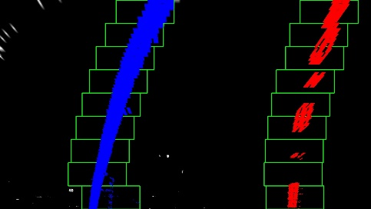

Image after Histogram Image after Histogram Image after Histogram

Find_from_Histogram_test1_ Find_from_Histogram_test2_ Find_from_Histogram_test3_  
minpix_50.jpg minpix_50.jpg minpix_50.jpg

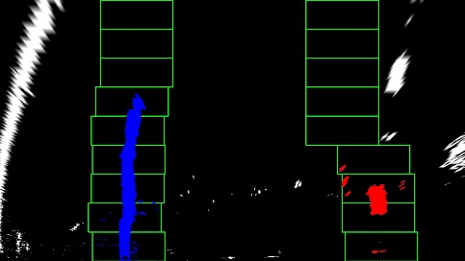 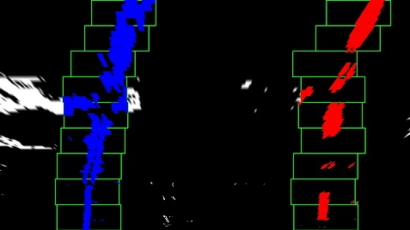 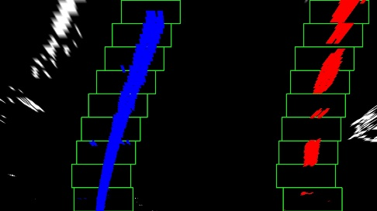

**(B)**

**(A)**

Image after Histogram Image after Histogram Image after Histogram

Find_from_Histogram_test4_ Find_from_Histogram_test5_ Find_from_Histogram_test6_  
minpix_50_bad.jpg minpix_50.jpg minpix_50.jpg

To avoid it, I changed parameter: **minpix = 200**, then the problem was solved **(C)**.

I checked other images and there are no degradation.

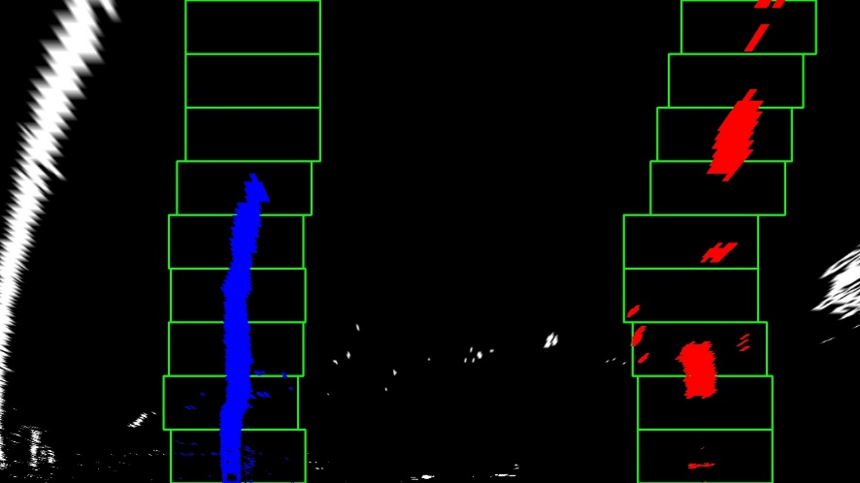

**(C)**

Image after Histogram with parameter tuning

Find_from_Histogram_test4_minpix_200.jpg

(3) fit_poly(): Calculate polynomial.

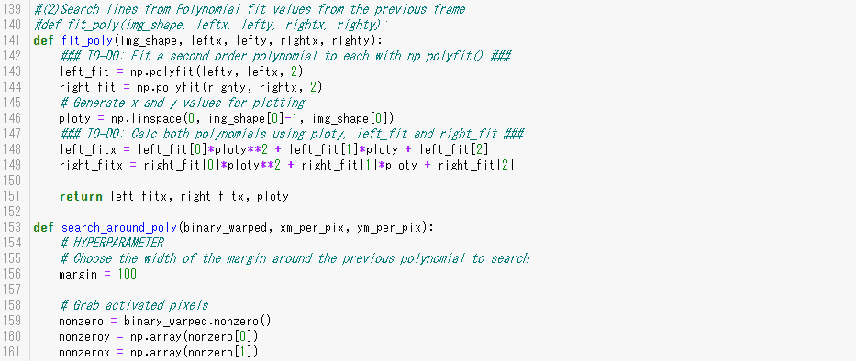

(4) search_around_poly (): Search lines from Polynomial fit values from the previous frame.



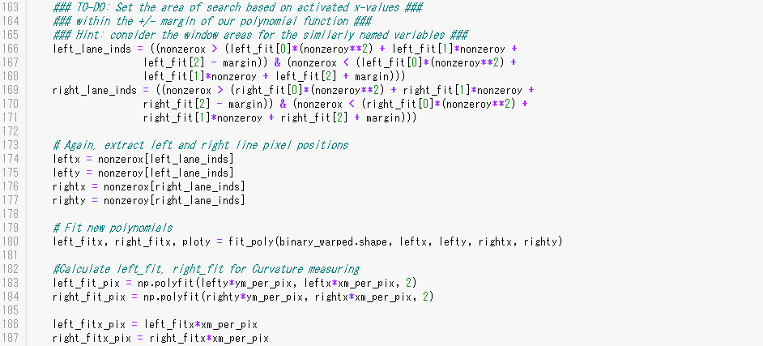

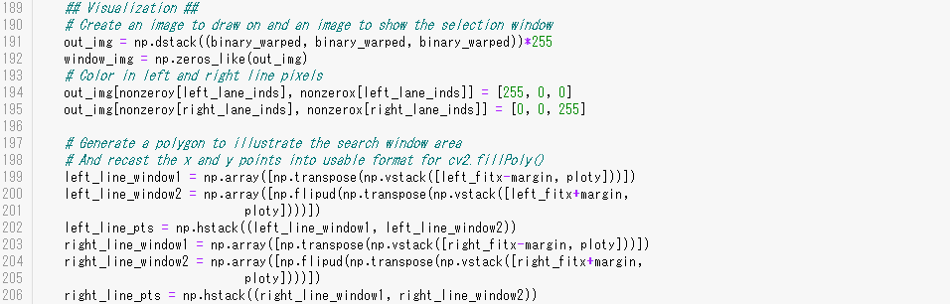

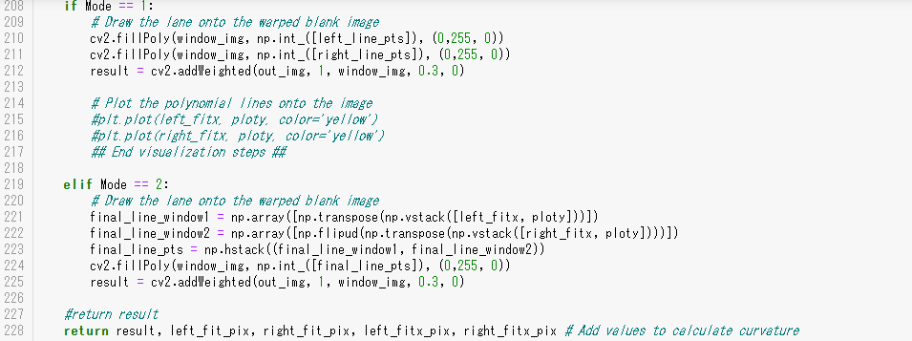

In fifth step, finally get the result of lane finding in bird view.

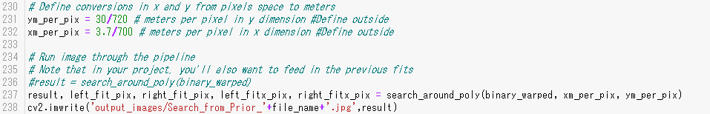

Data folder is “\output_images\5_Finding\Prior”.

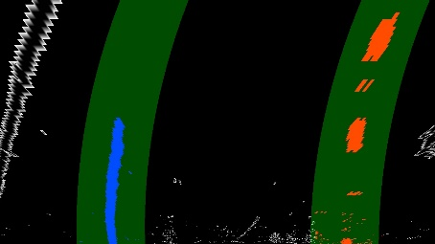 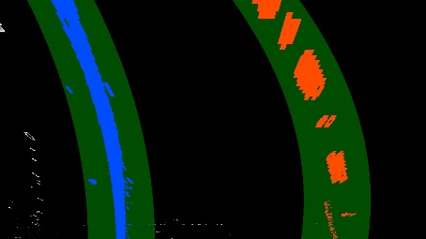 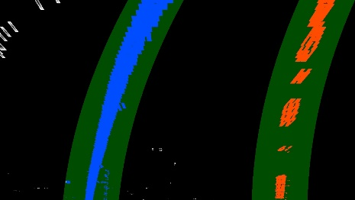

Image after Polynomial fit Image after Polynomial fit Image after Polynomial fit

Search_from_Prior_test1_ Search_from_Prior_test2_ Search_from_Prior_test3_  
minpix_200.jpg minpix_200.jpg minpix_200.jpg

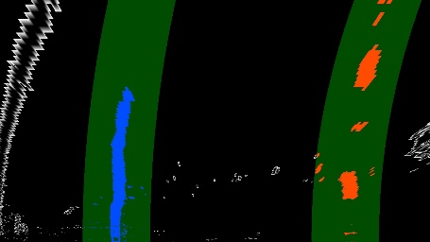 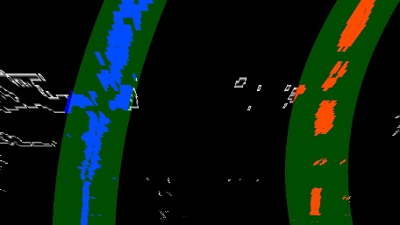 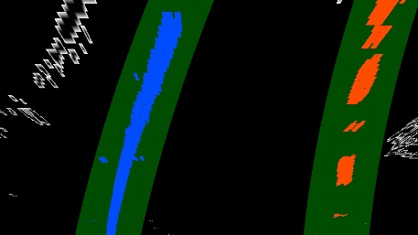

Image after Polynomial fit Image after Polynomial fit Image after Polynomial fit

Search_from_Prior_test4_ Search_from_Prior_test5_ Search_from_Prior_test6_  
minpix_200.jpg minpix_200.jpg minpix_200.jpg

Sixth, I measured curvature and vehicle position.

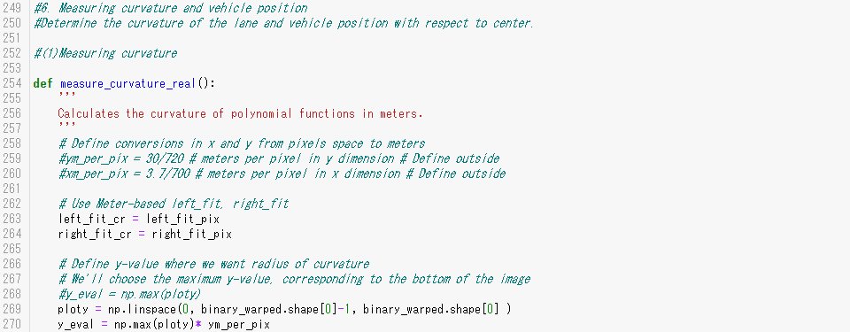

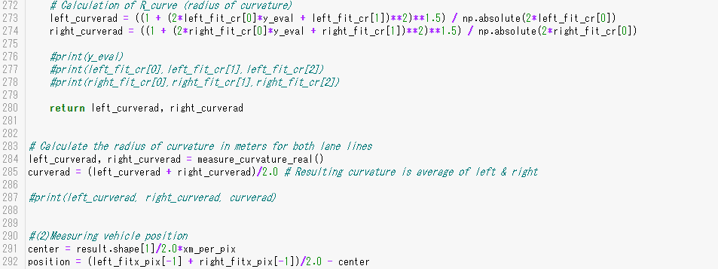

Seventh, I warped the found lane lines (green line area) from bird view to the original images.

I also put texts of curvature and vehicle position.

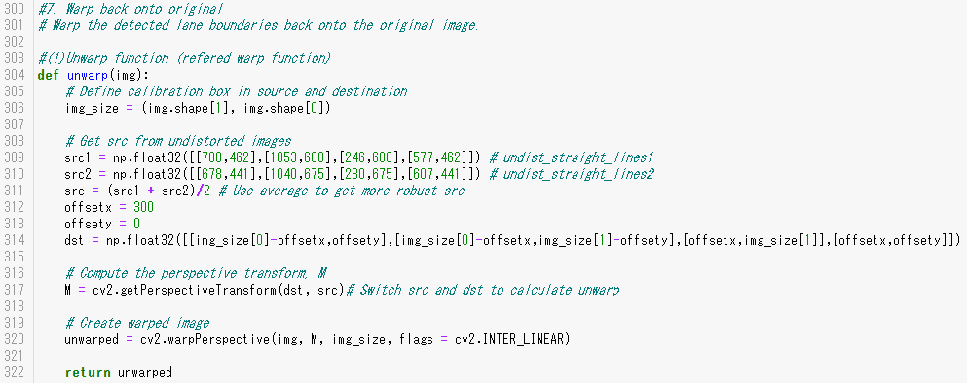

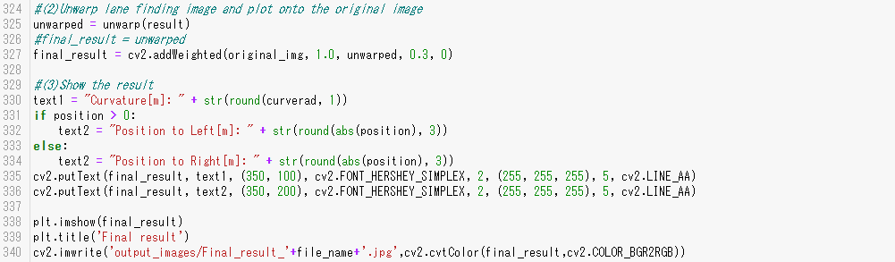

Data folder is “\ output_images\6_Result”.

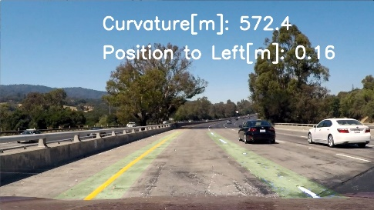 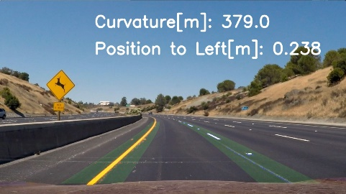 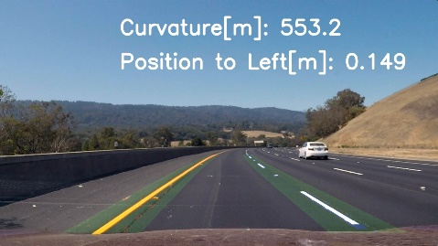

Image after unwarp Image after unwarp Image after unwarp

Final_result_test1.jpg Final_result_test2.jpg Final_result_test3.jpg  
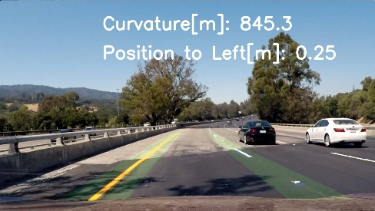 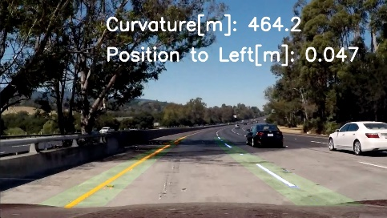 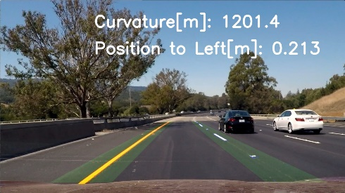

Image after unwarp Image after unwarp Image after unwarp

Final_result_test4.jpg Final_result_test5.jpg Final_result_test6.jpg

Finally eighth, I ran the video file “project_video.mp4”.

For the video, I changed from “Mode=1” to “Mode=2”, so only the following part in function “fit_poly()” was changed.

This means the green line area was changed from “on the lanes” to “between the lanes”.

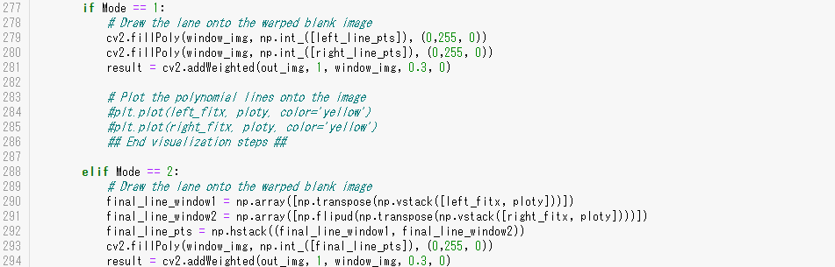

**(2) Result of my pipeline**

My pipeline mostly worked well with the vide file“project_video.mp4”.

The folder is “test_videos_output” and the video file name is “**project_video_output.mp4**”.

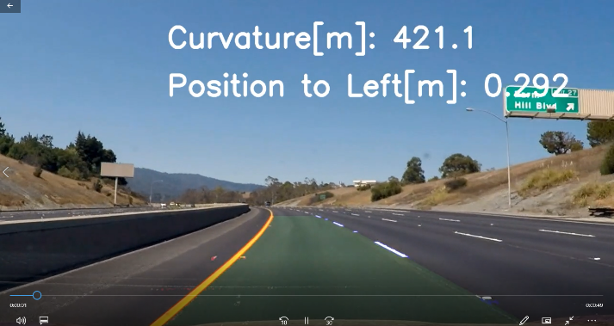 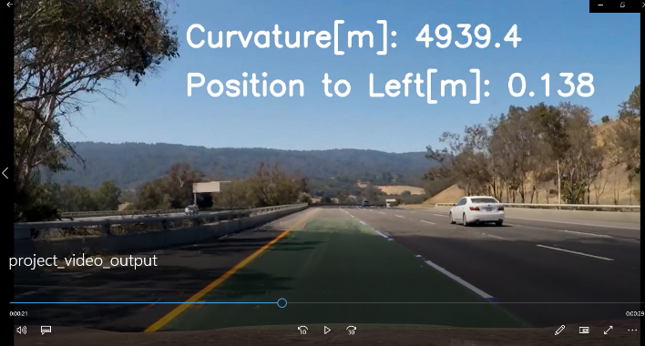

**(3) Identification of potential shortcomings with my current pipeline,  
and suggestion of possible improvements**

In the output video, there was just one moment when the left lane detected the edge of the wall as below **(A)**.

There may be the following countermeasures:

(i) Right lane looks match well **(B)**, and the width of lane can be assumed by High Definition Map Information **(C)**. In this case, we may be able to eliminate the left line candidate points that are far from the right line.

(ii) The left line mismatch occurred for just one moment, so we may be able to eliminate the sudden change of the lane line detection by smoothing with the former detected line data. The former data doesn’t have to be only one step before, but can include some steps before to make it more robust.

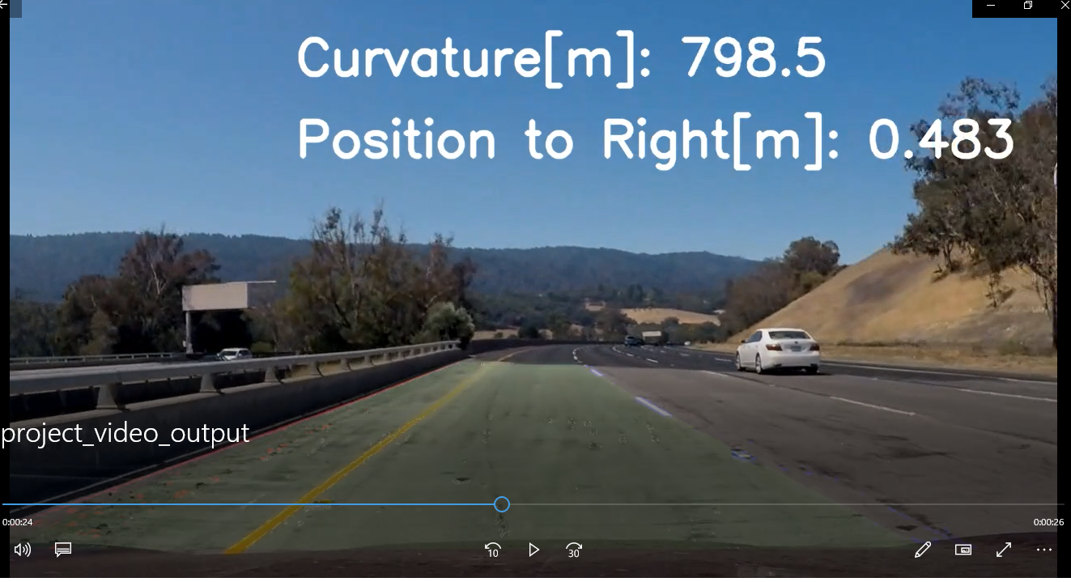

**(B)**

**(C)**

**(A)**

**project_video_output.mp4**

I also ran my pipeline with “challenge_video.mp4” and “harder_challenge_video.mp4”.

I found other 3 potential shortcomings with my current pipeline as bellow:

**(i) Robustness against bad road condition**

If there are clack lines on the road, my pipeline mismatched them **(A)**.

One of countermeasures is the same as previous page, which is assuming the width of lane by map information if the lane width is different from it **(B)**.

However, if the clack lines are deep there’s no idea which lane is real lane.

We may be able to assume the left lane by Sensor Fusion. We can detect the position of wall by Radar or LiDAR (C), and we know how much distance is there between wall and left lane by High Definition Map Information **(D)**,

so we can set the higher weight around the real left lane during lane detection algorithm.

We also may be able to assume the right lane by detecting another vehicle on the adjacent lane.

If there’s another vehicle in the right side, we can set lower priority on the right side clack line area **(E)**

to detect the real lane.

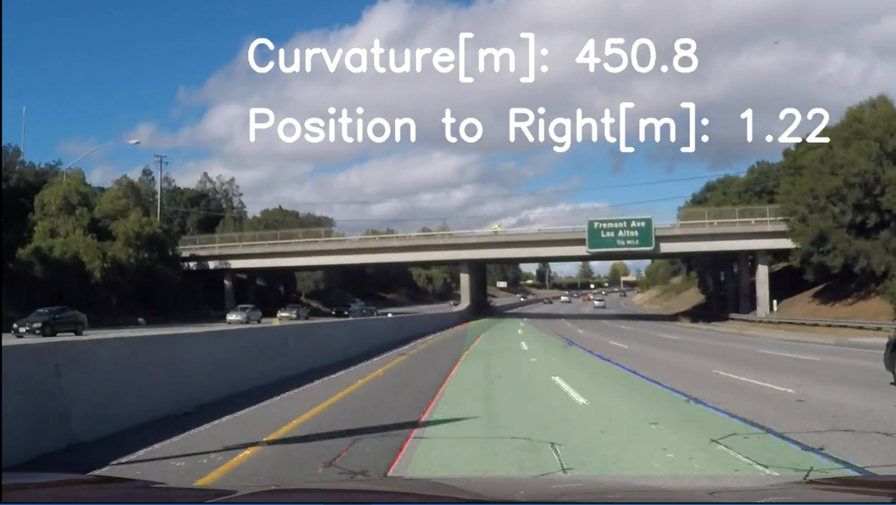

**(E)**

**(D)**

**(C)**

**(A)**

**(A)**

**challenge_video_output.mp4**

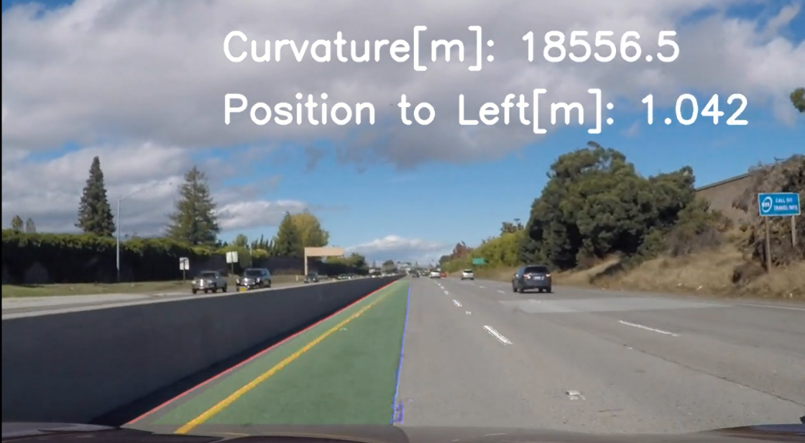

**(D)**

**(B)**

**(C)**

**(A)**

**challenge_video_output.mp4**

**(ii) Robustness against backlight**

**Red dots are left side** and **blue dots are right side**.

When there’s backlight and camera captured dots of light, the lane detection became unstable **(A)**.

There are some area without wall **(B)** and this is one side lane, so the countermeasures in the previous page don’t work.

If the time of backlight is short, we may be able to decrease the sudden change of the lane line detection by smoothing with the former detected line data, which was written in 2 pages before.

If the time of backlight is long, it’s better to hand over the vehicle control to human driver safely, then stop the autonomous driving system.

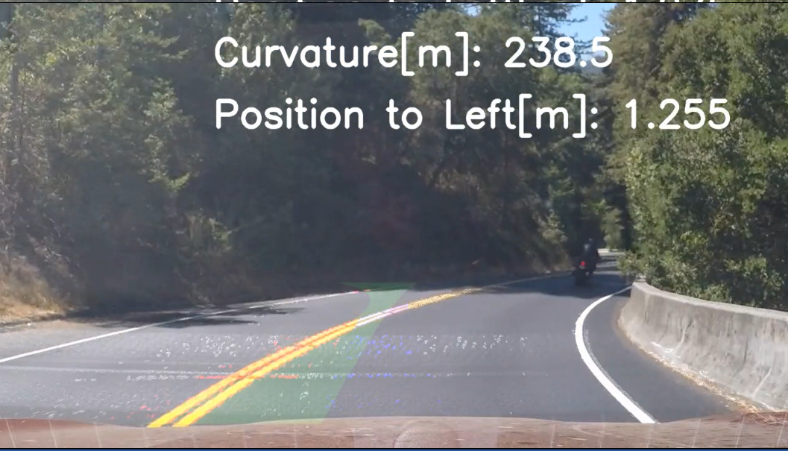

**(A)**

**harder_challenge_video_output.mp4**

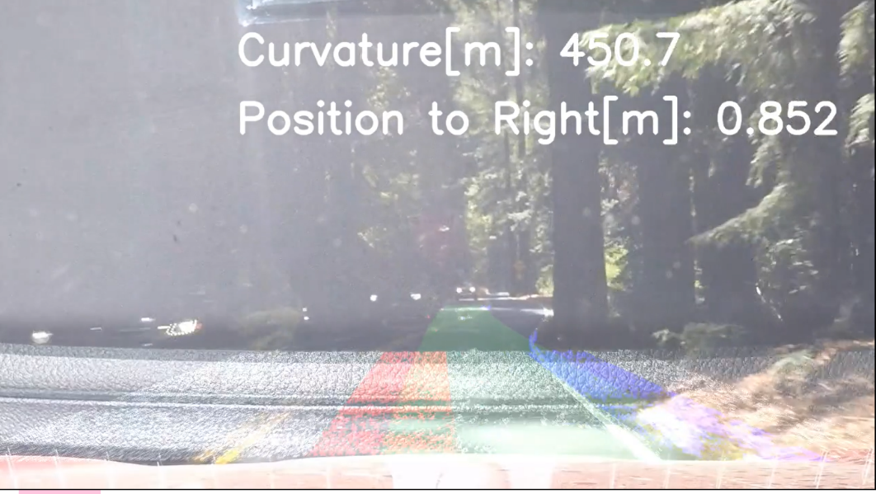

**(B)**

**(A)**

**harder_challenge_video_output.mp4**

**(iii) Robustness against steep curve**

In case of steep curve, the lane detection doesn’t match the real lane at all.

My pipeline covers only straight roads and gradual curves **(A)**.

However, on steep curves the coverage area should be changed like **(B)** and I should not detect dots in other area.

We can detect whether it’s steep curve or not by the following information:

(i) High Definition Map Information

(ii) Current angle of steering wheel

(iii) Current lateral acceleration

And also, decreasing vehicle speed helps self-driving in this scene by the following viewpoints:

* The curvature changes slowly, so lane detection by camera image will be more robust.
* Even if lane detection mismatches sometimes, the vehicle behavior will be slowly so it’s easier to recover to the stable status.

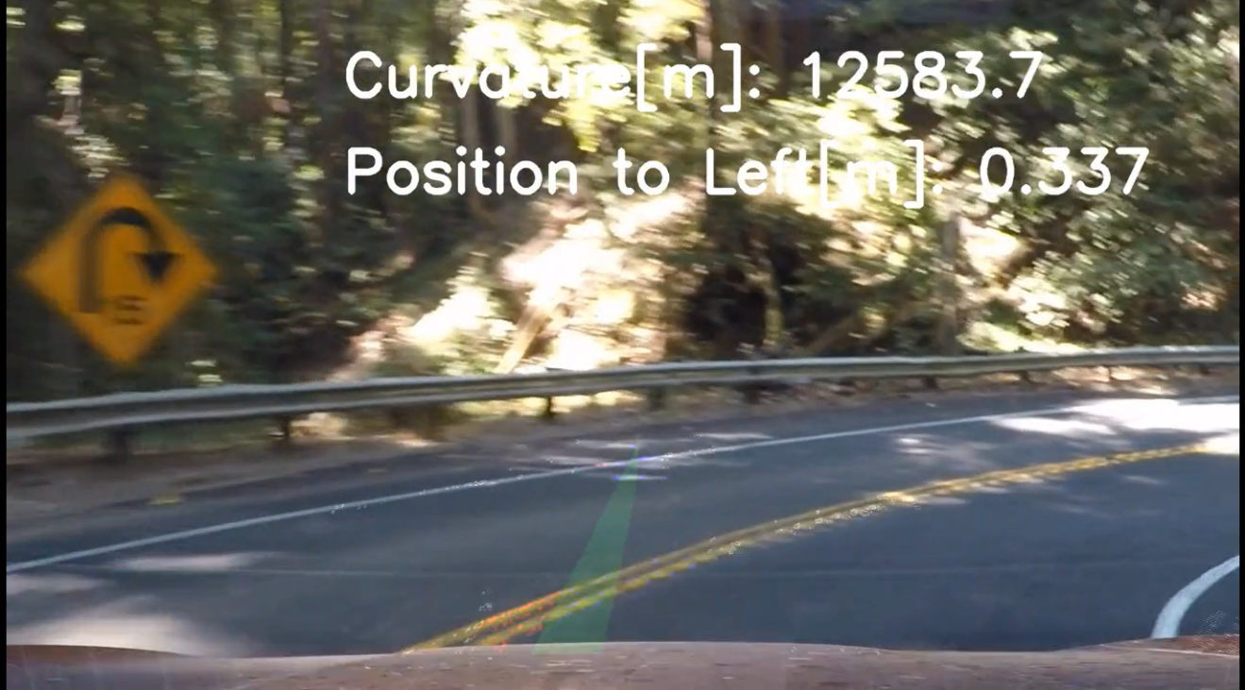

**(B)**

**(A)**

**harder_challenge_video_output.mp4**